EXP: 1.1
Transformation between Cartesian, Cylindrical and spherical coordinate system
PROGRAM:
clc;
x = input('Enter the value of X=');
y = input('Enter the value of Y=');
z = input('Enter the value of Z=');
r = sqrt(x^2 + y^2);
phi = atand(y/x);
disp('Cartesian to Cylindrical Coordinates [r phi z] = ');
disp([r phi z]);
r = sqrt(x^2 + y^2 + z^2);
theta = acosd(z/r);
phi = atand(y/x);
disp('Cartesian to Spherical Coordinates [r theta phi] = ');
disp([r theta phi]);
OUTPUT:
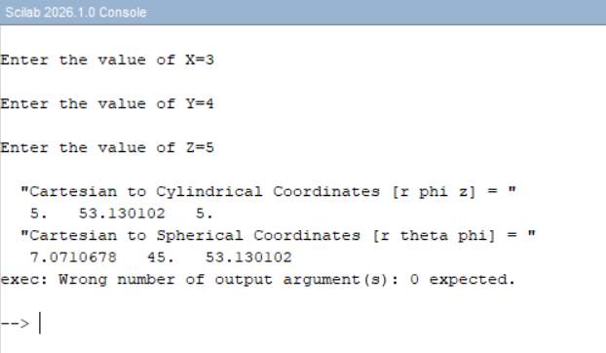
CALCULATION:
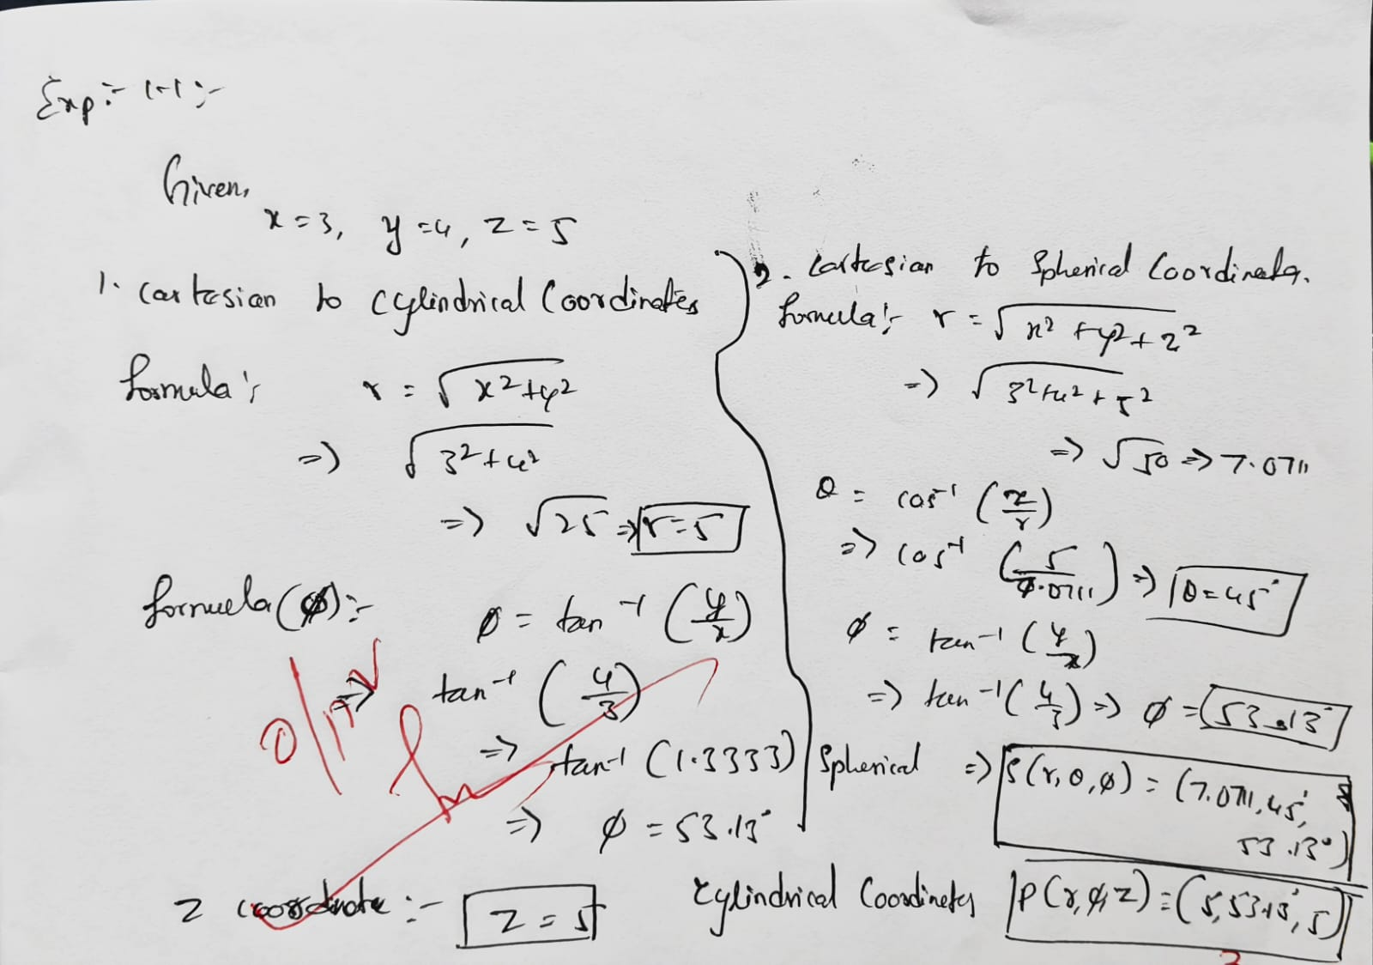

EXP: 1.2: Transformation of Cylindrical coordinate points into Cartesian and spherical
coordinate system
PROGRAM:
clc;

rho=input('Enter the value of rho=');
phi=input('Enter the value of phi=');
z=input('Enter the value of z=');
x=rho*cosd(phi);
y=rho*sind(phi);
disp('Cartesian Coordinates [x y z] = ');
disp([x y z]);
OUTPUT:
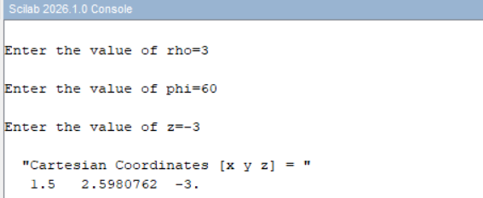
CALCULATION: 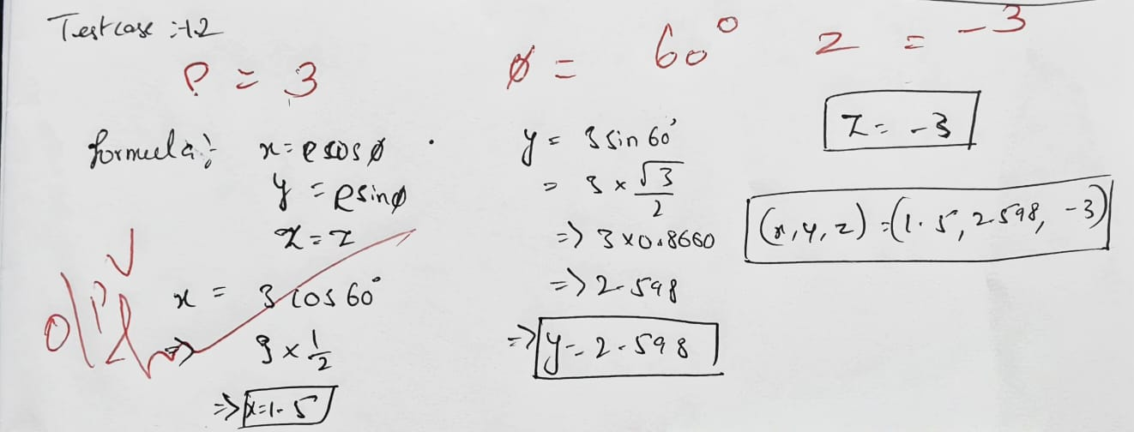
EXP 1.3: Transformation of spherical coordinate points into Cylindrical and Cartesian coordinate system
PROGRAM:
clc;
r=input('Enter the value of r=');
theta=input('Enter the value of theta=');
phi=input('Enter the value of phi=');
x=r*sind(theta)*cosd(phi);
y=r*sind(theta)*sind(phi);
z=r*cosd(theta);
disp('Cartesian Coordinates [x y z] = ');
disp([x y z]);
OUTPUT:
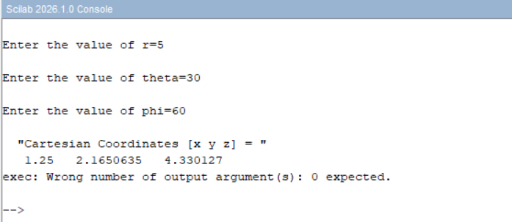
CALCULATION:
